<insert stakeholder’s name> Comments on the Proposed Department Circular,
" ADOPTING THE GUIDELINES AND PROCEDURES IN THE FUND SOURCING, UTILIZATION, ACCOUNTING/AUDIT OF RENEWABLE ENERGY TRUST FUND PURSUANT TO SECTION 28 OF THE RENEWABLE ENERGY ACT OF 2008”

Section | Comments/ Recommendations | Proposed/ Suggested Revisions
WHEREAS, Republic Act (RA) No. 9513, otherwise known as the “Renewable Energy Act of 2008,” declares as a policy of the State to, among others, increase the utilization of renewable energy by institutionalizing the development of national and local capabilities in the use of renewable energy (RE) systems, and promoting its efficient and cost-effective commercial application by providing fiscal and non-fiscal incentives;

WHEREAS, Section 28 of RA No. 9513 mandated the establishment of a RE Trust Fund (RETF) to enhance the development and greater utilization of renewable energy;

WHEREAS, Section 32, Rule 11 of Department Circular No. DC2009-05-0008, also known as the Rules and Regulations Implementing Republic Act No. 9513, provided the RETF general guidelines on the sources, exclusive administration, and utilization of the and that the RETF shall be exclusive used to:

- Finance the research, development, demonstration, and promotion of the widespread and productive use of RE systems for Power and Non-Power Applications;
- Provide funding to qualified research and development institutions engaged in RE studies undertaken jointly through public-private sector partnership, including provision for scholarship and fellowship for energy studies;
- Support the development and operation of new RE Resources to improve their competitiveness in the market: Provided, That the grant thereof shall be done through a competitive and transparent manner;
- Conduct nationwide resource and market assessment studies for the Power and Non-Power Applications of RE Systems;
- Propagate RE knowledge by accelerating, tapping, training, and providing benefits to institutions, entities, and organizations which can help widen the promotion and reach of RE benefits at the national and local levels; and
- Fund such other activities necessary or incidental to the attainment of the objectives of the Act;
WHEREAS, on 23 October 2018, the DOE issued Department Order (DO) No. DO2018-10-0018 entitled, “Adopting the Guidelines for the Operationalization of the Renewable Energy Trust Fund, and for other Purposes”, which governed the collection, administration, and utilization of the RETF;

WHEREAS, on 11 January 2019, the DOE issued Special Order No. SO2019-01-0003 entitled, “Creating the Department of Energy Committee for the Administration of the Renewable Energy Trust Fund”, which created the RETF Committee (RETFC) and its respective members and functions;

WHEREAS, pursuant to DO2018-10-0018, the RETFC shall:

- Develop and implement a competitive and transparent method of selecting projects to be funded by the RETF;
- Recommend for the approval by the Secretary of his/her authorized representative, the projects eligible to be funded by the RETF;
- Formulating the necessary mechanism for the transfer of funds to the RETF;
- Open with an existing Government Financial Institution a special trust account which shall be exclusively used for the RETF;
- Conduct regular meetings to monitor the implementation of the DO2018-10-0018; and
- Perform such other tasks as may be necessary to accomplish the foregoing functions.

WHEREAS, to fully implement the program, there is a need to set specific guidelines and procedures for the fund sourcing, utilization, accounting/audit of the RETF;

Section 1. Title. This Circular shall be known as “Adopting the Guidelines and Procedures in the Fund Sourcing, Utilization, Accounting/Audit of the Renewable Energy Trust Fund” or the “RETF Guidelines”.

Section 2. Definition of Terms. This Circular hereby adopts, by reference, the terms defined in RA No. 9513, its Implementing Rules and Regulations, and other relevant laws and issuances. Furthermore, the following terms, as used in this Circular, shall be defined as follows:

- Accounting Division – refers to the division under Financial Services of the DOE, which formulates policies, plans and programs related to the Department’s general accounting services and ensures effective implementation thereof and compliance with government rules and regulations;

- Audit - an objective examination and evaluation of the financial records and reports of the fund made by competent authorities vested with the mandate to make sure that the financial records and reports are a fair and accurate representation of the transactions of the fund;

- Billing - refers to the process of raising and sending statement of accounts to RETF Contributors and requesting them to settle their dues in compliance with Section 34 Rule 11 of DC No. DC 2009-05-008;

- Bureau of Internal Revenue (BIR) – refers to the government agency created pursuant to Reorganization Act No. 1189;

- BP 100-B Form – refers to Budget Preparation Form for the estimated revenues and expenditures of the Off-Budgetary Accounts and Custodial Funds;

- Collection – refers to the act or process of presenting a statement of account for payment by RETF Contributors and compelling them to remit such funds into the RETF;

- Conventional Energy Resource Compliance Division (CERCD) - refers to the division under Financial Services of DOE, which formulates policies, plans and programs related to the compliance of Conventional Energy service contractors with their financial obligations as provided for in their Conventional Energy service contracts and ensures effective implementation thereof in accordance with government rules and regulations, and evaluates financial capabilities of prospective Conventional Energy service contractors;

- Department of Budget and Management (DBM) – refers to the government agency created under Executive Order No. 25, as amended;

- Department of Energy (DOE) – refers to the government agency created pursuant to Republic Act No. 7638, is the implementing agency of all the rules and regulations under the Republic Act No. 9513, Renewable Energy Act of 2008. It is also the administrator of the Renewable Energy Trust Fund;

- Department of Environment and Natural Resources (DENR) - refers to the government agency created pursuant to Executive Order No. 192, is the implementing agency of all the rules and regulations under the Republic Act No. 8749, Philippine Clean Air Act;

- Disbursement - refers to a wide range of payment types made in a specific period from the RETF;

- Emission fees – refers to the collection of DENR from the industrial and motor vehicle discharges based on the Section 13 of R.A. No. 8749, Emission Charge System;

- Estimated Revenues – refers to the estimated collection from various RETF sources;

- Financial Services – refers to the bureau under the DOE, which formulates and implements fiscal policies, programs and regulations, including those on indigenous energy resource service contractors; monitors the utilization of government-administered energy funds; and provides staff support services pertaining to budget and accounting;

- Government Share - refers to the amount due the National Government and Local Government Units from the exploitation, development, and utilization of conventional and renewable energy resources;

- Net annual dividends – refers to the annual cash dividends declared by PNOC;

- Net Income – refers to the profit after tax and net assistance/subsidy/financial assistance/contribution to NGAs/LGUs/NGOs/POs and others;

- Philippine Amusement and Gaming Corporation (PAGCOR) – refers to the government-owned and controlled corporation created pursuant to Presidential Decree Nos. 1067-A, 1067-B, 1067-C, as amended by PD Nos. 1399, 1632, 1869, and Republic Act No. 9487;

- Philippine Charity Sweepstakes Office (PCSO) – refers to the government-owned and -controlled corporation created pursuant to the Republic Act No. 1169;

- Philippine National Oil Company (PNOC) – refers to the government-owned and controlled corporation created pursuant to Presidential Decree No. 334, as amended;

- Power Compliance Division (PCD) – refers to the division under the Financial Services of DOE, which formulates policies, plans and programs related to the compliance of energy resource developers and/or power producer on the granting of benefit to the concerned local government units and ensures effective implementation thereof in accordance with government rules and regulations, monitors DOE- administered energy funds as well as the utilization thereof;

- Remittance – refers to act or process of any payment made, sent and transferred to the RETF;

- Renewable Energy Management Bureau (REMB) – refers to bureau under DOE, which is created for the implementation of Republic Act 9513. Implement policies, plans and programs related to the accelerated development, transformation, utilization, and commercialization of renewable energy resources including emerging energy technologies;

- Renewable Energy Trust Fund (RETF) – refers to the special account administered by DOE, established to enhance the development and greater utilization of renewable energy;

- RETF Account – refers to the Cash in Bank-Local Currency, Current Account opened in the Land Bank of the Philippines (LBP) and maintained as Trust Fund by DOE;

- RETF Contributors or Sources of Fund Agencies/Entities – identified as the RETF sources pursuant to Section 28 of Republic Act 9513 or Renewable Energy Act of 2008 and Section 34 Rule 11 of DC No. DC 2009-05-0008;

- Treasury Division (TD) – refers to the division under the Administrative Services of DOE, which formulates policies, plans and programs related to DOE’s cashiering services and fund management and ensures effective implementation thereof and compliance with government accounting and auditing rules and regulations; and

- Technical Services Management Division (TSMD) – refers to the division under REMB tasked to perform as the Secretariat to the RETF Committee pursuant to SO No. 2019-01-0003.

Section 3. RETF Guidelines. All concerned government agencies shall be guided on the process of sourcing; billing, collection, and remittance; utilization; accounting, and audit of the RETF provided herein.

3.1. Estimates. The REMB, in coordination with the RETF contributors, shall submit to the Accounting Division of the DOE the estimated revenues and expenditures of the RETF account on or before February 15 of the following fiscal year.

- All concerned government agencies and DOE units shall be guided by the below process flow on the estimates on revenue and expenditure for the RETF:

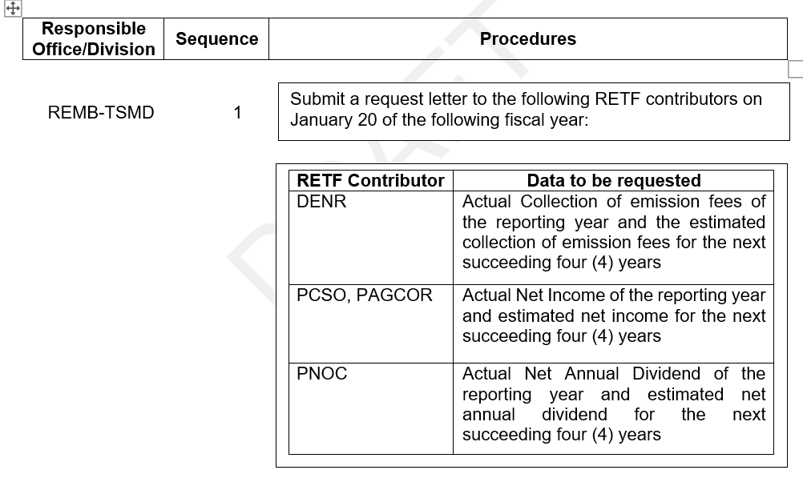
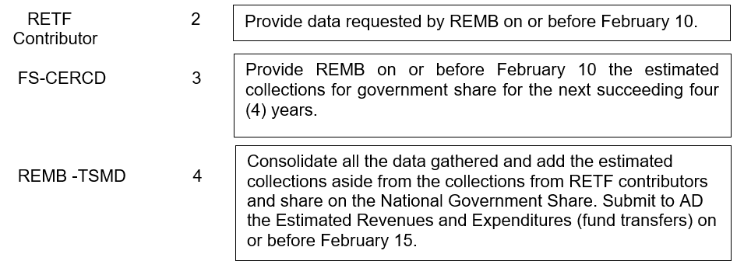
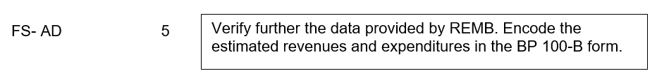

3.2. Billing, Collection and Remittance. The procedures of billing, collection, and remittance of the RETF shall be divided into three, namely: Collection from RETF Contributors; Collection from the share of RETF on the 60% National Government share on collections from conventional energy service contractors; and Collection of the DOE on the contributions, grants, and donations in the form of cash, any revenue generated from the utilization of the RETF and proceeds from fines and penalties imposed under RA No. 9513.

- All concerned government agencies and DOE units shall be guided by the process flows provided below:

- Collection from RETF Contributors;

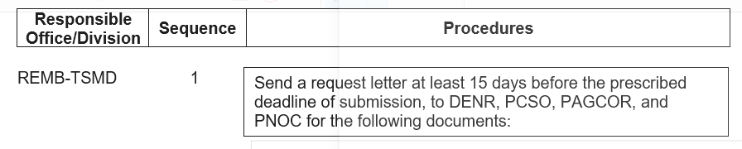
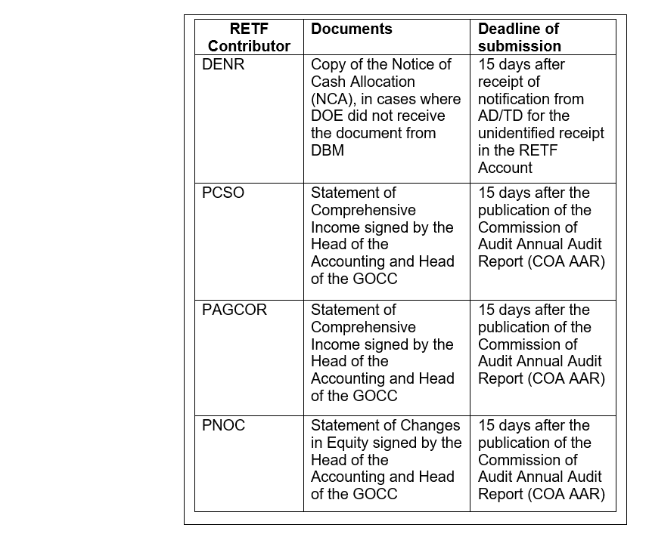
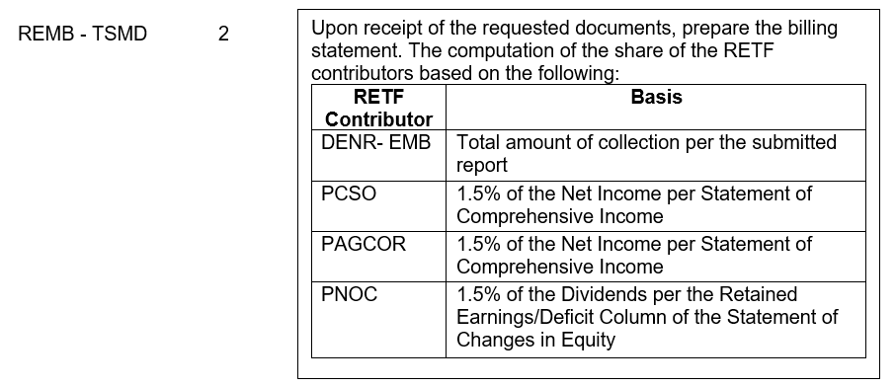
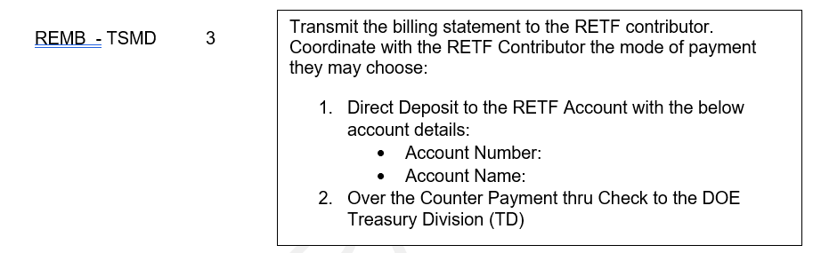
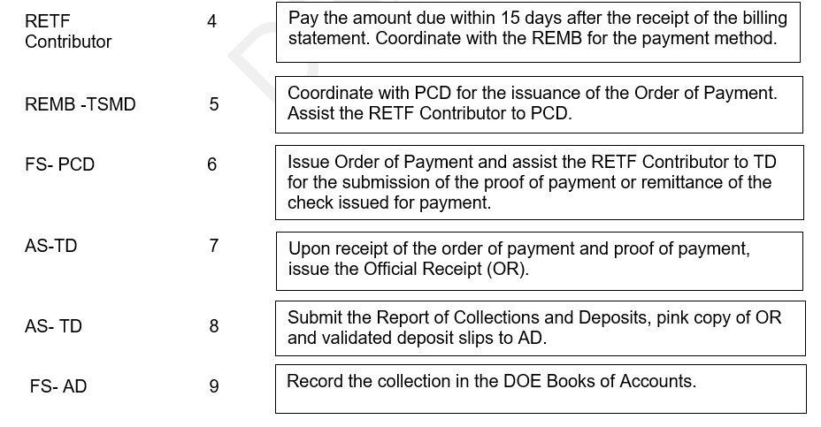
- Collection from the share of RETF on the 60% National Government share on collections from conventional energy service contractors;

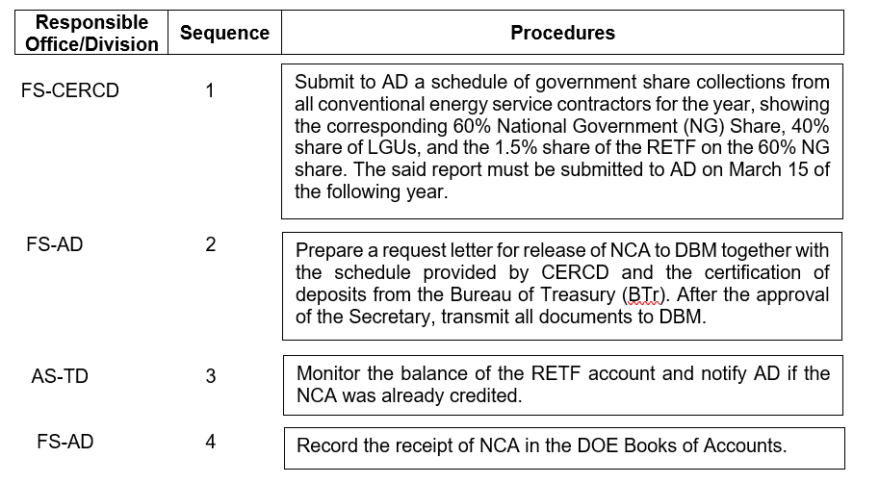

- Collection of the DOE on the contributions, grants, and donations in the form of cash, any revenue generated from the utilization of the RETF and proceeds from fines and penalties imposed under RA No. 9513.

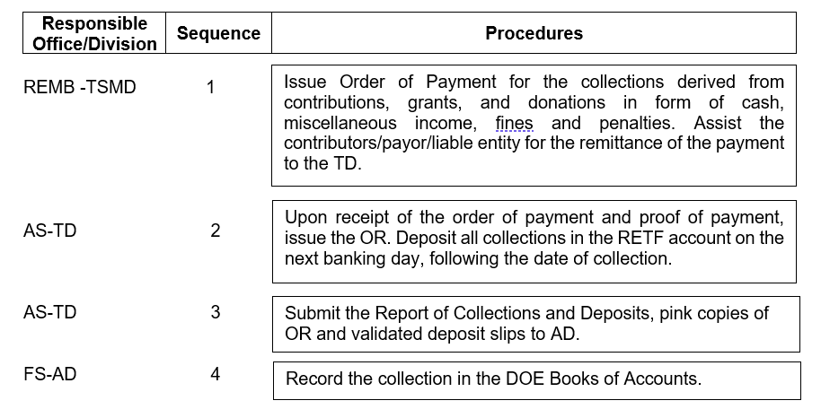

Section 4. Operations Manual. Within three (3) months from the effectivity of this Circular, the DOE shall issue the RETF Operations Manual, consistent with the objectives of the RETF under section 28 of the RE Act of 2008. The manual shall include Qualifications of Eligible Organizations, Types of Financial Support, Institutional Structures and Mechanisms, and Application and Approval Process, among others.

Section 5. Accounting/Audit. All transactions pertaining to the RETF Account shall be recorded in the DOE Books of Accounts under Fund Cluster 07 as Custodial Funds following the government accounting procedures and auditing standards.

Section 6. Government Support. This Circular shall primarily be supported by the following government agencies, as mandated under Section 34 of the Rules and Regulations Implementing the RE Act of 2008:

- DBM;
- BIR;
- DENR;
- PCSO;
- PAGCOR; and
- PNOC.

Section 7. Repealing Clause. Any prior issuances, orders, or Circulars inconsistent with this Department Circular are hereby repealed, amended, or modified accordingly.

Section 8. Separability Clause. If any provision of this Circular is declared invalid or unconstitutional, the other provisions that are not affected shall remain valid and subsisting.

Section 9. Effectivity. This Circular shall take effect fifteen (15) days after its publication in two (2) newspapers of general circulation. Copies of this DC shall be filed with the University of the Philippines Law Center – Office of the National Administrative Register.

