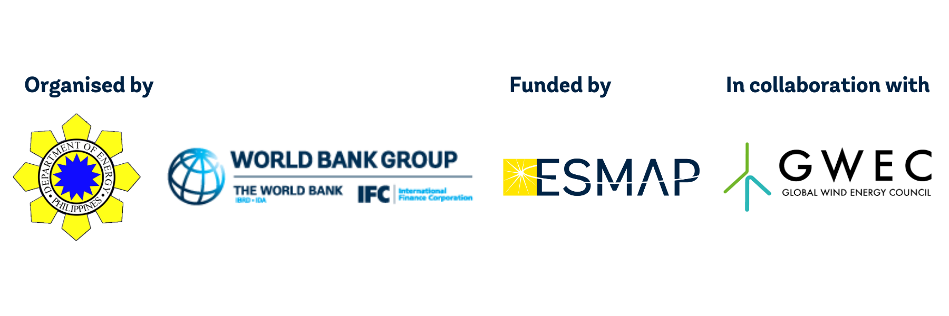
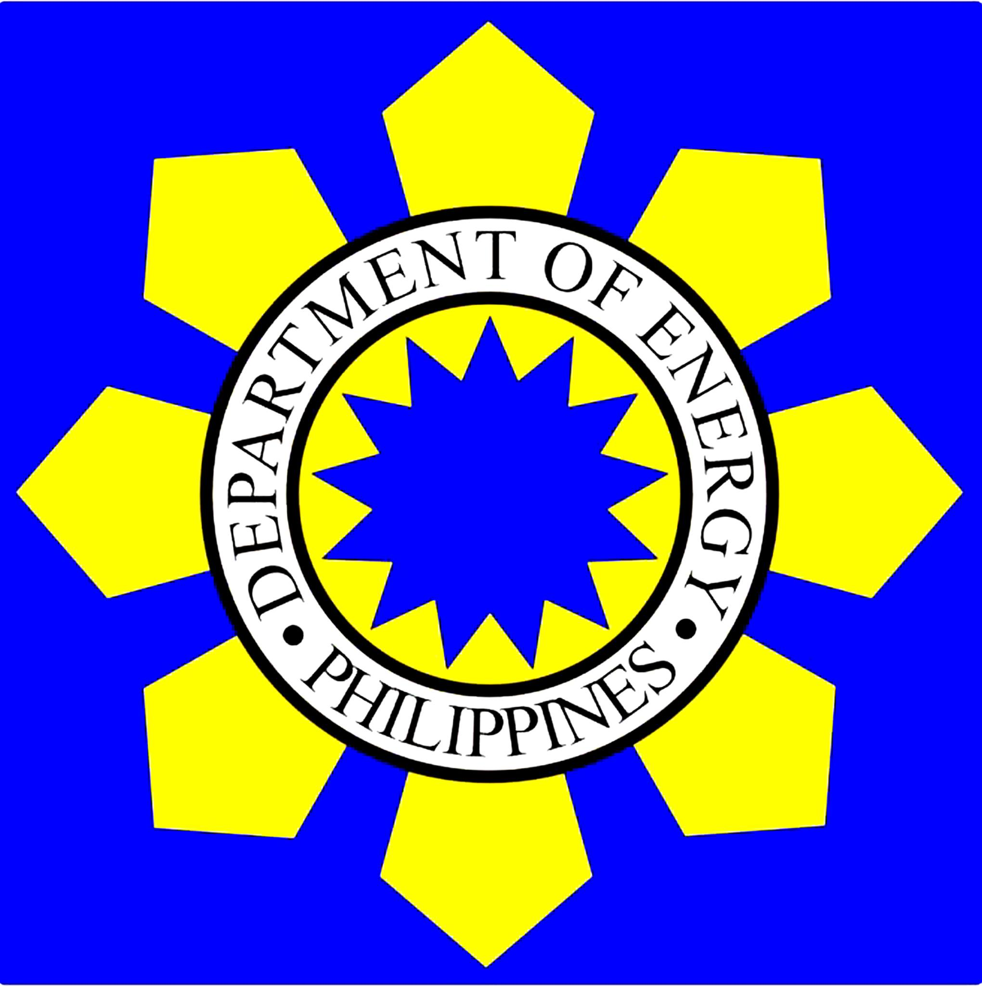

Philippines Offshore Wind Roadmap Launch Event

Communications Kit

About the Event

Date: 20 April 2022

Time: 13:00-17:00 GMT+8

Location: Virtual

Description:
The Philippines has immense offshore wind potential, with the World Bank estimating over 178 GW of technical offshore wind potential in the country. With a rapidly rising energy demand and goals to increase renewable energy shares to 50% in the country’s energy mix by 2040, offshore wind can play an important role in increasing energy security and decarbonisation efforts in the Philippines. Building up the country’s offshore wind market can also support the growth of many socioeconomic benefits including job creation, local economic growth, and low-cost sustainable energy.

On April 20, 2022, the Philippines’ Department of Energy (DOE) and the World Bank Group, with funding from the Energy Sector Management Assistance Program (ESMAP), will be launching the first-ever Philippines Offshore Wind Roadmap which will lay out the potential and concrete next steps for developing a robust offshore wind industry in the Philippines. The roadmap launch will bring together stakeholders from across the public and private sector to discuss technical, economic, environmental, social, employment, and financing aspects of establishing the country’s offshore wind market.

The half-day launch event is open to the public with Q&A.

Event Link: https://bit.ly/3Jgt5kf

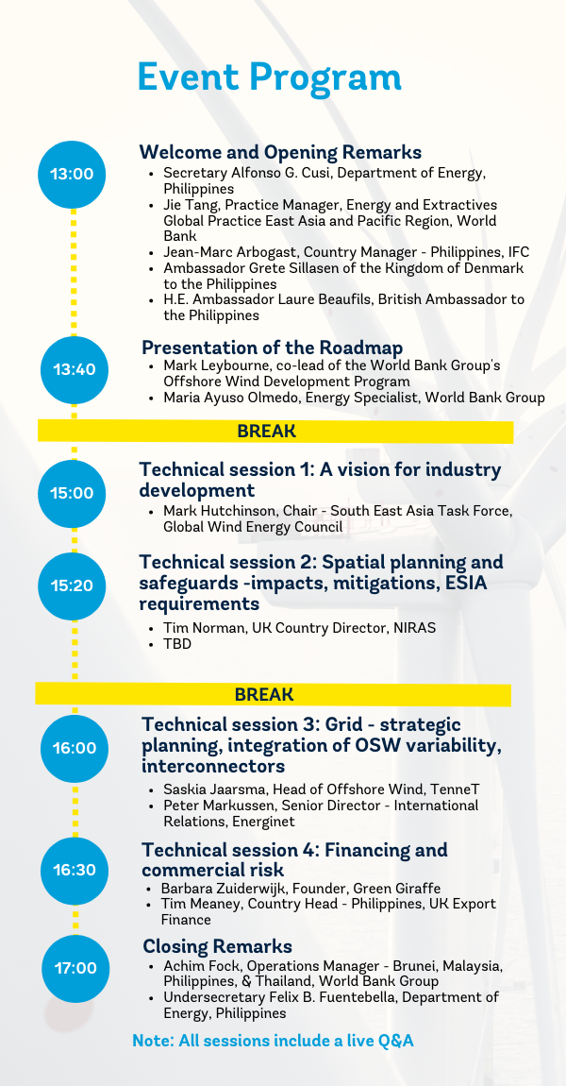

Social Media

Draft Twitter Post – General
#DYK that the Philippines🇵🇭 has 178GW of #offshorewind potential? Join the launch of the first Philippines Offshore Wind Roadmap with @doe_ph & @WBG_Energy, funded by #ESMAP. Learn more on how the country can tap into its offshore wind potential. Register👉 https://bit.ly/3Jgt5kf

Draft LinkedIn/Facebook Post – General
#DYK that the Philippines🇵🇭 has 178GW of #offshorewind potential? On 20 April from 13:00-17:00 GMT+8, join the launch of the first Philippines Offshore Wind Roadmap, organised by @doe_ph and @World Bank with funding from #ESMAP, to learn more on how the country can tap into its offshore wind potential and create significant socioeconomic benefits for the local economy.

The roadmap launch will bring together local and international stakeholders from across the public and private sector to discuss technical, economic, environmental, social, employment, and financing aspects of establishing the country’s offshore wind market.

Find out more about the event and register here 👉 https://bit.ly/3Jgt5kf

Draft Twitter Post – Speaker
Join me along with other private and public stakeholders from across the world at the launch of the first Philippines 🇵🇭 Offshore Wind Roadmap on 20 April, organised by @doe_ph & @WBG_Energy & funded by #ESMAP, to kick-start the country's #offshorewind journey. Register👉 https://bit.ly/3Jgt5kf

Draft LinkedIn/Facebook Post – Speaker
Join me along with other private and public stakeholders from across the world at the launch of the first Philippines 🇵🇭 Offshore Wind Roadmap on 20 April, organised by @doe_ph and @The World Bank with funding from #ESMAP, to kick-start the country's #offshorewind journey.

Find out more about the event and register here 👉 https://bit.ly/3Jgt5kf

Relevant Tags
Twitter | LinkedIn | Facebook
@WBG_Energy | @The World Bank | @WorldBankPhilippines
@doe_ph | @Department of Energy Philippines | @ Department of Energy Philippines

Relevant Hashtags
#OffshoreWind
#EnergyTransition
#WeHaveTheEnergyAbility
#DOEPH
#WBEnergy
#ESMAP
#DOEPH 🇵🇭
#EPowerMo
#EnerhiyangAtin
#EnergyAbility
#ESafety
#ESecure
#EDiskarte

For any questions about the event and communications kit, please contact Alyssa Pek at apek@worldbank.org.

